**Routing in Web Applications**

* Routing matches different URLs to different views in the UI.
* In React, each URL matches a specific React component, creating a route.
* When a specific URL is visited, the corresponding React component is rendered.

**Examples of Routes**

* The homepage is shown for example.com.
* The login component is shown for /login.
* After a successful login, the user is redirected to /app.

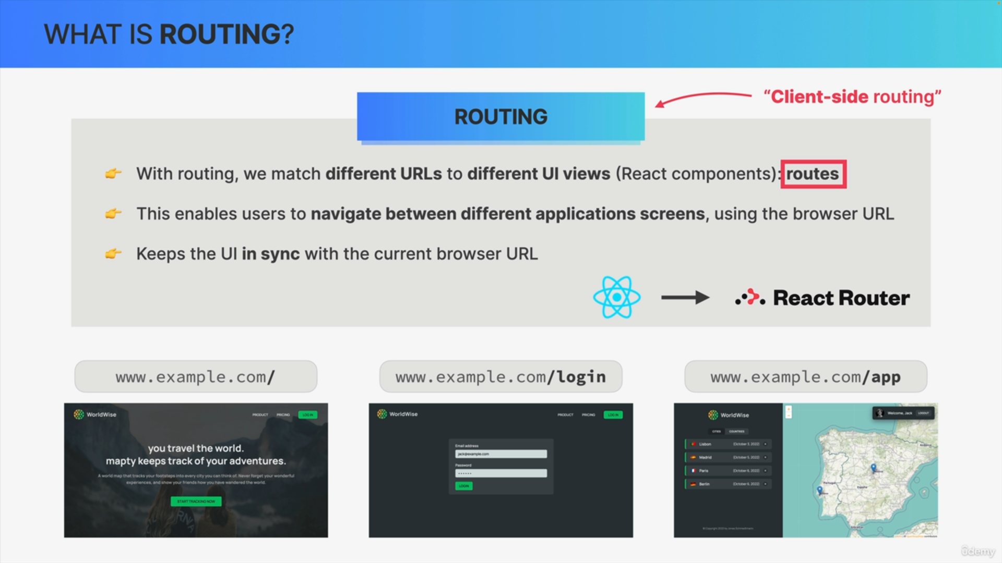

**Client-Side Routing**

* Enables navigation between different screens using links and the browser URL.
* Keeps the UI in sync with the current browser URL.
* Commonly implemented on the client-side in the user's browser.
* Front-end frameworks usually have built-in client-side routing capabilities.

**React and Third-Party Packages**

* React relies on third-party packages for functionalities, including routing.
* React Router is the most used third-party library for routing in React.

**Single-Page Applications (SPAs)**

* SPAs are web applications executed entirely on the client side in the browser.
* Rely heavily on routes where different URLs correspond to different views.
* Clicking a special link changes the URL without reloading the page.
* JavaScript updates the DOM, making the web application feel like a native app.

**React Router in SPAs**

* Changes in the URL trigger DOM updates by rendering the corresponding component.
* This cycle can repeat indefinitely, providing seamless navigation without page reloads.
* SPAs can still fetch external data from a server via web APIs without reloading the page.

**Professional Applications**

* Complex applications require routing to handle multiple URLs.
* Routing is essential for building true single-page applications.

**Conclusion**

* All React apps are inherently single-page applications due to React's ability to update the DOM without reloading.
* To create professional, complex SPAs, mastering React Router is essential.
* The next step involves implementing real single-page applications with React Router.

